MADHYA PRADESH TEXTBOOK CORPORATION
ERP SYSTEM
Business Understanding Document
Prepared for internal stakeholder review
Document Type: Requirements & Process Brief | Version 1.0
August 2026

1. Executive Summary
The Madhya Pradesh Textbook Corporation (MPTBC) is introducing a unified Enterprise Resource Planning (ERP) system to digitize and coordinate the complete lifecycle of textbook production and distribution across the state — from demand generation at the school level through to final delivery. Today this lifecycle spans multiple disconnected functions — demand aggregation, printer empanelment, paper procurement, and depot-level dispatch — that are coordinated manually or through fragmented systems. The proposed ERP consolidates these functions into a single, role-based platform that gives every stakeholder, from a District-level RSK official to a Depot Manager, real-time visibility into where a demand or a consignment stands.
The system is organized around six functional modules — User Management, HRMS, Distribution, Printing, Paper Procurement, and Depot Operations — each mapped to specific organizational roles with clearly bounded responsibilities. Two upstream systems, RSK (for Classes 1–8) and CPI (for Classes 9–12), feed approved textbook demand into the ERP via API, while Open Market Sellers can register and raise demand manually within the system itself.
The key business objectives of this initiative are:
- Eliminate manual hand-offs between the demand, printing, paper, and depot functions by giving all four a shared, single source of truth.
- Provide end-to-end traceability of a textbook demand from initiation to physical delivery, including printer performance and challan verification.
- Standardize vendor management for both printers and paper suppliers through structured registration, rate approval, and capacity tracking.
- Support two distinct distribution channels — free Government distribution (BEO/BRC) and commercial Open Market sales — from a common depot inventory.
- Strengthen governance through role-based access control, so each user only sees and actions the workflow steps relevant to their function.

2. System Architecture Overview
The ERP is architected as six cooperating modules sitting on a common data layer. User Management and HRMS are foundational/cross-cutting modules — they establish who may use the system and in what capacity — while Distribution, Printing, Paper, and Depot form the operational backbone that carries a textbook demand through to physical delivery. The flow diagram in Section 7 shows how these operational modules connect end to end.

2.1 Role-Based Access Summary
Role | Primary Module(s) | Core Responsibility
System Administrator | All modules | Full system configuration and access control
RSK / CPI Official | Distribution (via API) | Initiate / approve textbook demand for Classes 1–8 (RSK) and 9–12 (CPI)
Distribution Officer | Distribution | Manage demand, issue work orders, manage depot profiles
Printing Section Officer | Printing | Manage printing operations and printer registration
Paper Procurement Officer | Paper | Manage paper procurement and vendor registration
Depot Manager | Depot | Manage inventory, verify challans, dispatch books
Open Market Seller | Distribution, Depot | View availability, place demand, track orders

2.2 Integration Points Between Modules
- Distribution → Printing: approved demand is shared for print-order generation.
- Printing → Distribution: print orders trigger work-order issuance to the selected printer.
- Distribution → Paper: book quantity data informs the paper requirement.
- Printing → Paper: paper specification (GSM, size, quantity) is shared for procurement.
- Distribution → Depot: depot profiles and print orders are shared for inbound stock planning.
- Printing → Depot: printed books are received into depot inventory.
- HRMS → All modules: employee-to-role mapping determines system access.

3. Module-wise Description

3.1 User Management
Purpose: Central administration of roles and access rights so every user interacts only with the functions relevant to them.
- Key functions: role creation and assignment; access-level configuration; user activation/deactivation.
- Dependencies: consumes role mappings created in HRMS; governs access across all other modules.
- Inputs: employee-role mapping from HRMS. Outputs: authenticated, role-scoped access to the other five modules.

3.2 HRMS — Employee Registration
Purpose: Maintain the authoritative record of MPTBC employees and link each employee to a system role.
- Key functions: capture personal and professional details; document upload and storage; role mapping.
- Dependencies: feeds User Management with the employee-to-role linkage.
- Inputs: employee onboarding data and documents. Outputs: verified employee profiles mapped to roles.

3.3 Distribution Section
Purpose: The demand-aggregation and coordination hub — it receives textbook demand from all three channels, routes it to Printing, and prepares the depot network to receive stock.
- Key functions: receive approved demand via API from RSK (Classes 1–8) and CPI (Classes 9–12); receive manual demand from the Open Market; share demand with Printing; issue work orders to a selected printer; create depot profiles (manager and stock details); share print orders with depots.
- Dependencies: upstream of Printing and Depot; consumes demand from RSK/CPI APIs and Open Market Sellers.
- Inputs: RSK/CPI API demand, manual Open Market demand. Outputs: validated demand to Printing, work orders to printers, depot profiles and print orders to Depot.

3.4 Printing Section
Purpose: Converts approved demand into executable print orders and manages the empanelled printer base.
- Key functions: receive approved demand from Distribution; group demand by class, subject, and region; generate print orders; register printer profiles (name, contact, type, approved rates, capacity, agreement upload).
- Dependencies: receives input from Distribution; supplies print orders back to Distribution (for work orders) and paper specification to the Paper Section; supplies finished books to Depot.
- Inputs: approved demand, printer registration data. Outputs: grouped print orders, paper specification, printed books to Depot.

3.5 Paper Section
Purpose: Ensures the right quantity and specification of paper is procured and supplied in time for printing.
- Key functions: receive book-quantity details from Distribution; receive paper-specification details from Printing; register paper-supply vendors; prepare a paper-supply schedule; the Central Paper Depot receives paper from the vendor.
- Dependencies: consumes data from both Distribution and Printing; supplies paper (indirectly, operationally) into the printing cycle.
- Inputs: book quantities, paper specifications, vendor registrations. Outputs: paper supply schedule, received paper stock at the Central Paper Depot.

3.6 Depot
Purpose: The physical inventory and last-mile dispatch point, reconciling incoming stock and routing it to its final destination.
- Key functions: receive books from the printer and update stock; verify challans against physical goods; register Open Market Sellers; dispatch books either to BEO & BRC (Government, depot-transported, free distribution) or to registered Open Market Sellers (self-transported).
- Dependencies: receives depot profiles and print-order intimation from Distribution; receives physical stock from Printing; serves both Government and Open Market channels.
- Inputs: incoming book consignments, challans, depot/print-order data. Outputs: verified stock, dispatched consignments to BEO/BRC or Open Market Sellers.

4. Key Workflow Summary
The end-to-end process below traces a single textbook demand from creation to final delivery. A full visual representation is provided in Section 7.

Step 1 — Demand Creation
Demand originates from one of three sources: the RSK Official (Classes 1–8) or CPI Official (Classes 9–12), both submitting approved demand automatically via API; or an Open Market Seller, who raises demand manually within the system.

Step 2 — Demand Validation (Decision Point)
The Distribution Officer reviews incoming demand. If validated, the demand proceeds to Printing; if rejected, it is returned to the originating channel for correction and resubmission.

Step 3 — Demand Grouping & Print Order Generation
The Printing Section groups validated demand by class, subject, and region, and generates print orders. This runs in parallel with printer registration, so only empanelled printers with approved rates and verified capacity are eligible for order allocation.

Step 4 — Work Order & Paper Procurement (Parallel Tracks)
Two things happen in parallel once print orders are generated: the Distribution Officer issues a formal work order to the selected printer, and the Paper Section is triggered — receiving book quantity from Distribution and paper specification from Printing — to schedule and procure paper, which is received at the Central Paper Depot.

Step 5 — Production & Depot Receipt
The printer produces the books and supplies them to the Depot. The Depot Manager receives the consignment and updates stock levels.

Step 6 — Challan Verification (Decision Point)
Every incoming consignment is verified against its challan. A mismatch routes the consignment back for reconciliation before it can be accepted into dispatch-ready stock; a match clears it for dispatch.

Step 7 — Dispatch Routing (Decision Point) & Delivery
Verified stock is dispatched along one of two channels: to BEO & BRC offices for free Government distribution (depot-transported), or to a registered Open Market Seller for commercial sale (self-transported, following seller registration and demand placement).

5. Integration Points

5.1 API Integrations
Integration | Direction | Purpose
RSK API | Inbound to Distribution | Approved textbook demand for Classes 1–8
CPI API | Inbound to Distribution | Approved textbook demand for Classes 9–12

5.2 Inter-Module Data Flow
- Demand data flows Distribution → Printing → (Work Order) back to Distribution → Paper / Depot.
- Vendor/capacity data (printer and paper-vendor registrations) flows into the order-generation and procurement-scheduling steps respectively.
- Physical-stock data flows Printing → Depot, reconciled against challans before it becomes dispatch-ready inventory.
- Role and access data flows HRMS → User Management → all operational modules.

5.3 External System Dependencies
- RSK and CPI systems are external systems of record for school-level demand and must expose a stable API contract for demand submission and status updates.
- Document storage (for employee documents, printer agreements, and challans) is assumed to sit on a shared document-management layer accessible to HRMS, Printing, and Depot.

6. Key Assumptions
- RSK and CPI are treated as external, authoritative sources for already-approved demand; the ERP does not re-approve this demand, only validates and ingests it.
- “Approval” at the Distribution stage refers to a completeness/eligibility check by the Distribution Officer, not a re-adjudication of RSK/CPI's own approval.
- Printer and paper-vendor empanelment (registration, rate approval) is assumed to be a prerequisite, ongoing process that runs ahead of and in parallel with order allocation, rather than a blocking step inside a single demand cycle.
- User Management and HRMS are treated as cross-cutting/foundational modules rather than steps in the linear demand-to-delivery flow, and are therefore represented as supporting modules rather than nodes in the Section 7 flow diagram.
- “Challan mismatch” is assumed to route back to the Depot receipt step for reconciliation rather than automatically triggering a returns process; the exact reconciliation workflow is expected to be confirmed during detailed design.
- Open Market Seller demand is manual at intake but, once validated, follows the same Printing/Paper/Depot pipeline as RSK/CPI demand.

7. Complete Flow Diagram
The diagram below shows the complete demand-to-delivery flow across the four operational modules — Distribution, Printing, Paper, and Depot — including the two upstream demand APIs, the three decision points (demand validation, challan verification and dispatch routing), and the two final delivery channels. The flow is laid out in six sequential stages and, for legibility at page size, is presented in two connected parts: Part A covers demand intake through print planning and work-order issuance; Part B continues from that point through paper procurement, production, depot receipt and final dispatch. The grey connector bars mark where Part A hands over to Part B.

Legend
Colour | Represents
Orange | External demand sources (RSK, CPI, Open Market Seller)
Blue | Distribution Section process step
Green | Printing Section process step
Yellow / Gold | Paper Section process step
Purple | Depot process step
Teal | Final delivery channel
Red diamond | Decision point (validation / verification / routing)
Grey band | Process stage grouping (Stages 1–6 of the end-to-end flow)
Grey bar | Off-page connector — continues in the other part of the diagram
Dashed arrow | Supporting or master-data input (registration, intimation, resubmission)

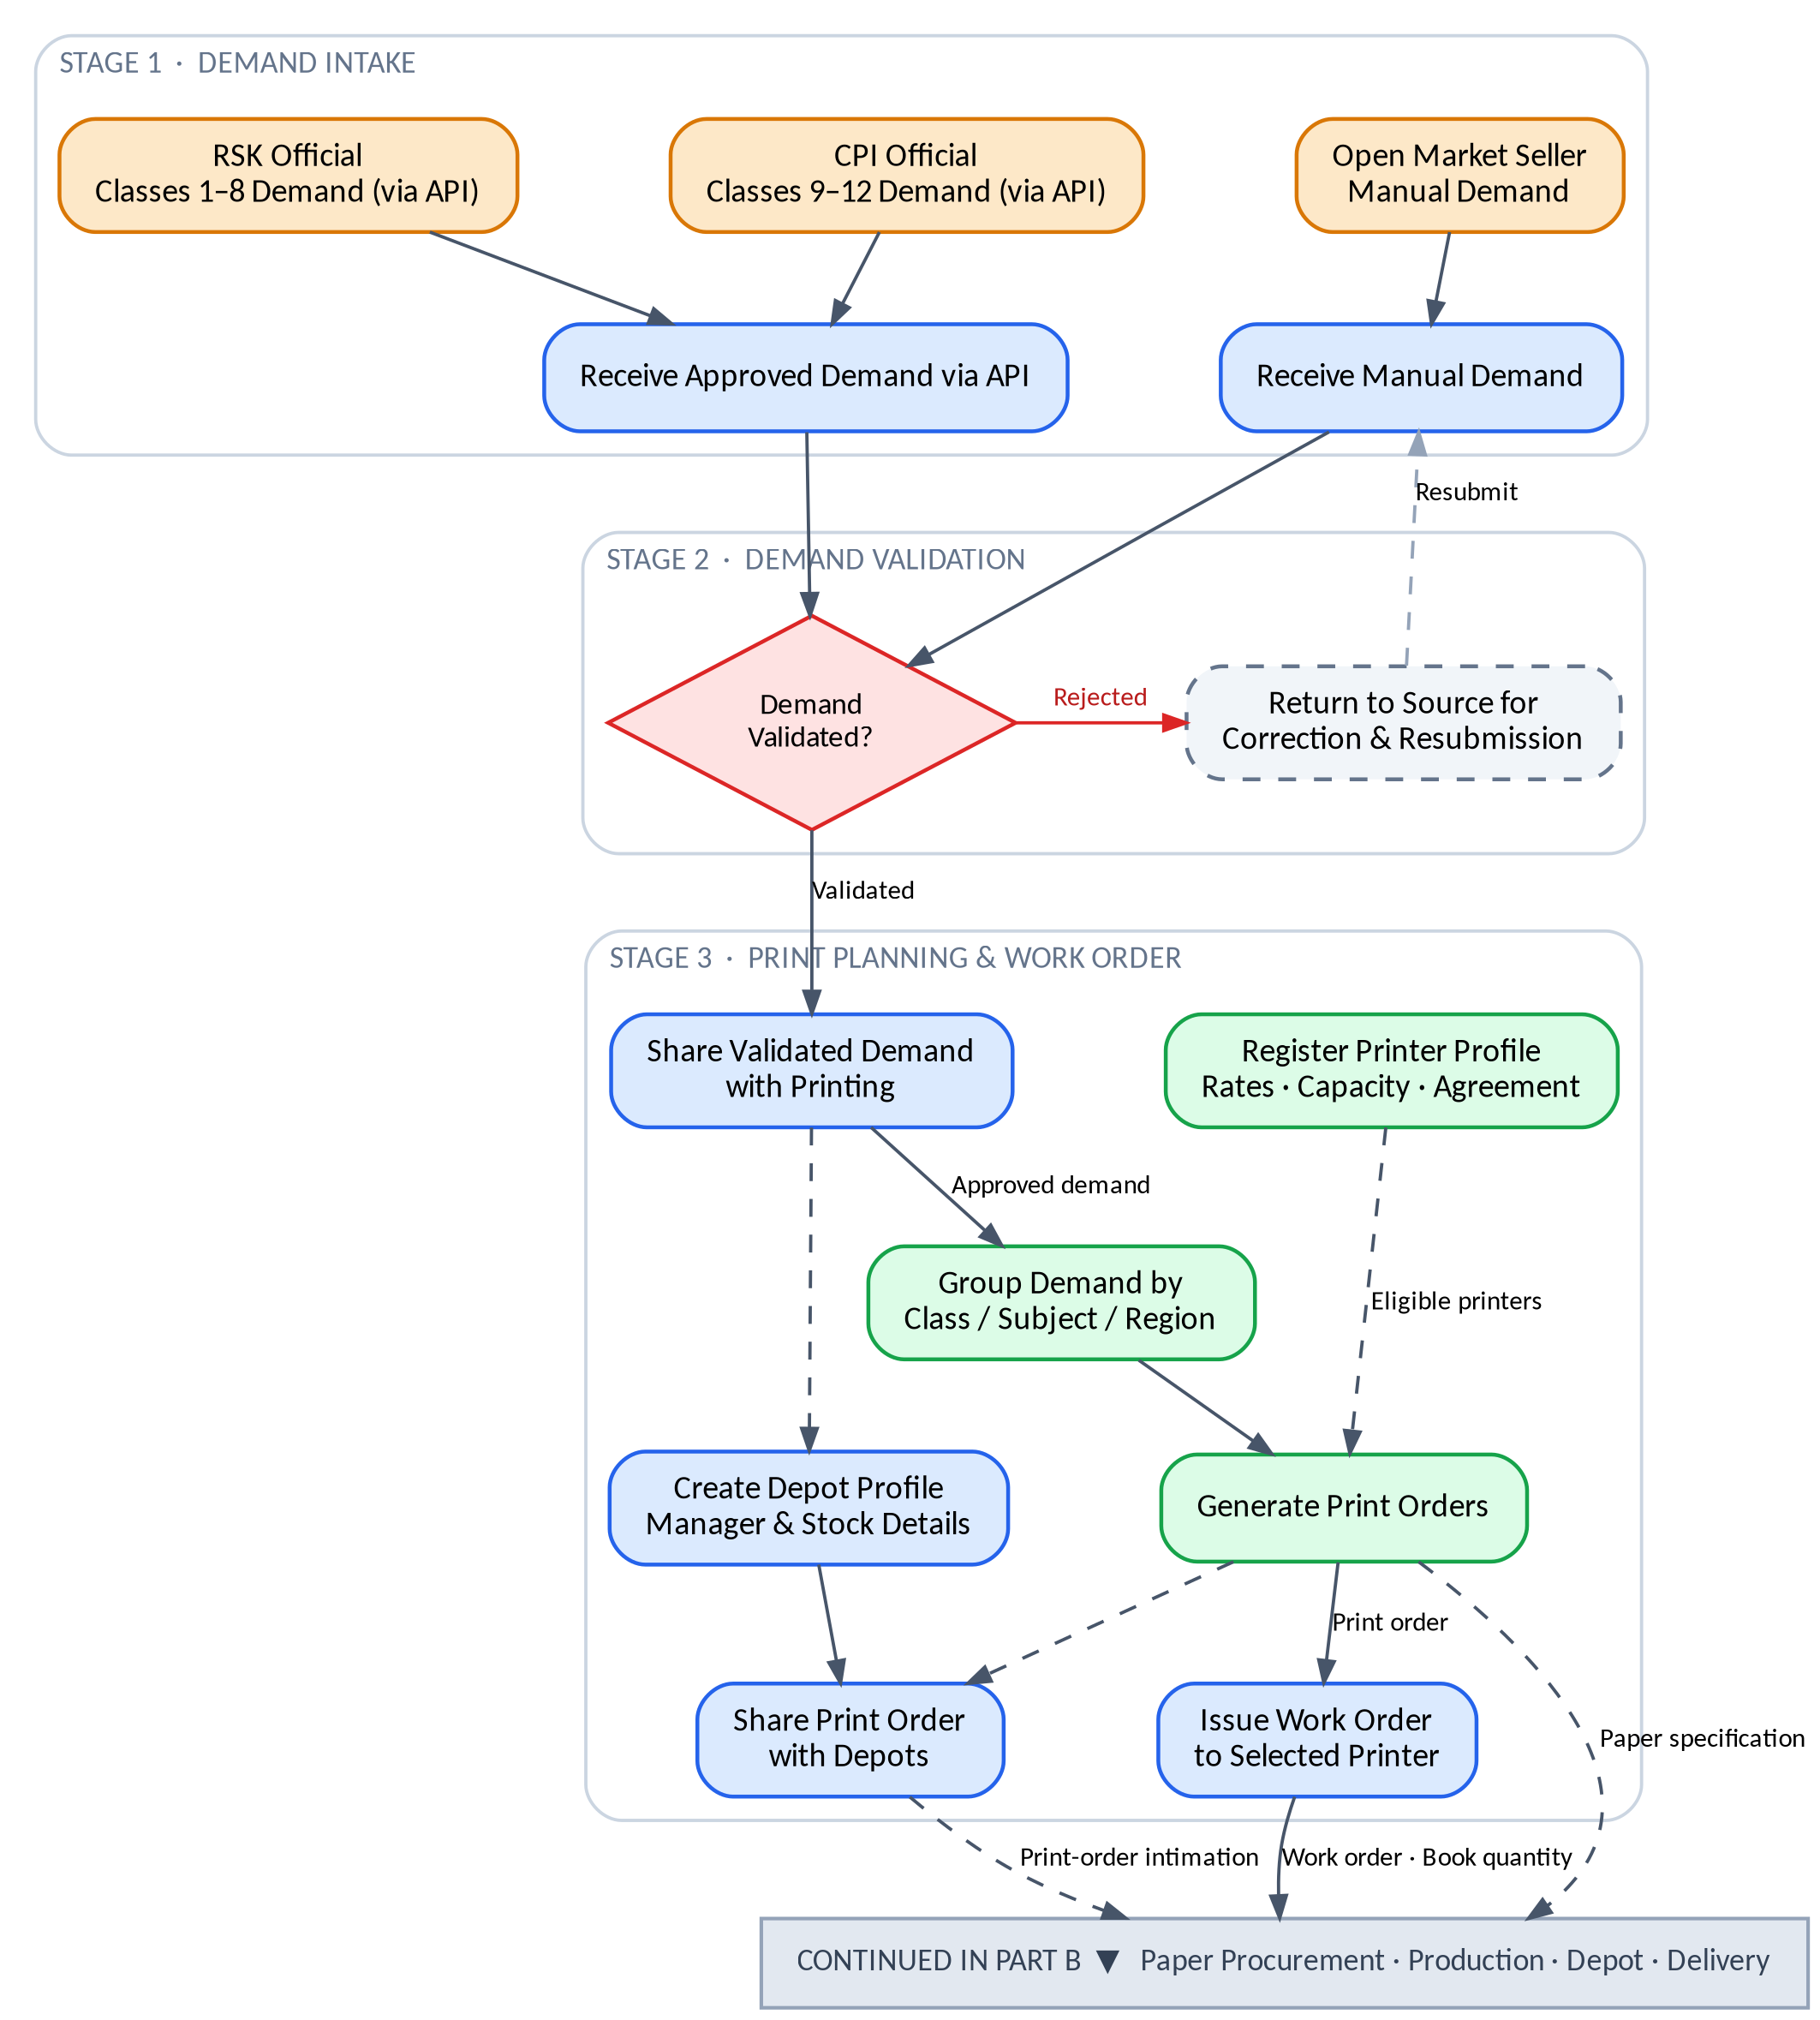
Figure 1: Part A — Demand Intake, Validation and Print Planning (Stages 1–3)

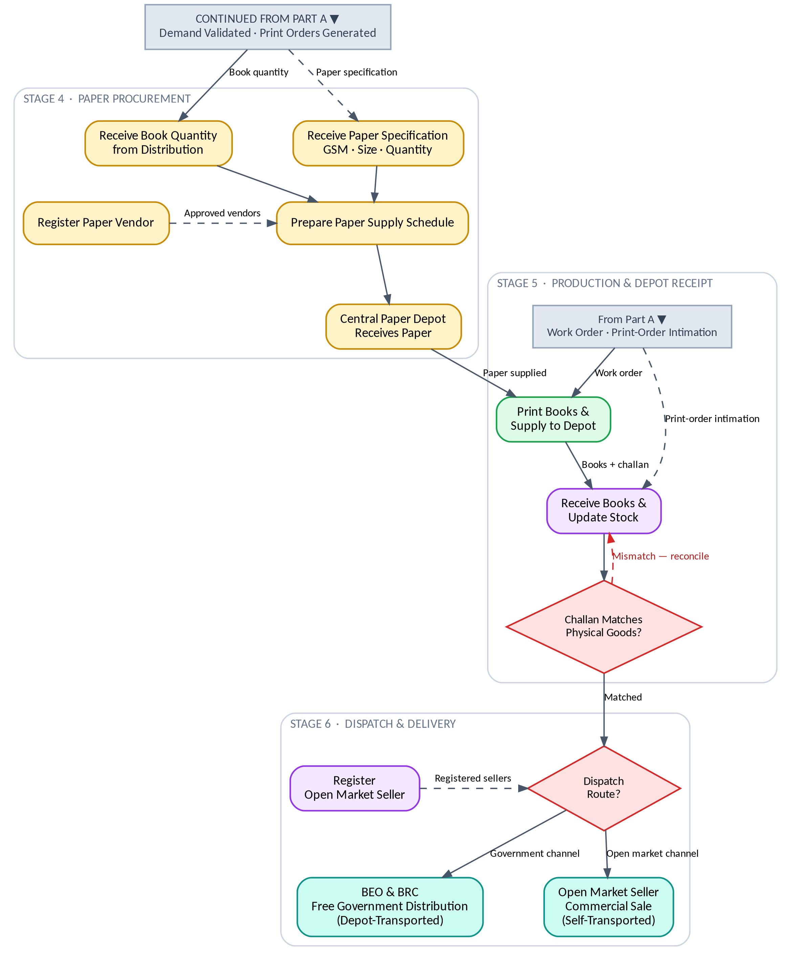
Figure 2: Part B — Paper Procurement, Production, Depot Receipt and Delivery (Stages 4–6)

8. Glossary of Acronyms
Acronym | Full Form
ERP | Enterprise Resource Planning
HRMS | Human Resource Management System
RSK | Rajya Shiksha Kendra (State Education Centre — source of Classes 1–8 demand)
CPI | Coordinator of Public Instruction (source of Classes 9–12 demand)
BEO | Block Education Officer
BRC | Block Resource Centre
API | Application Programming Interface

